Chi Omega
3.8
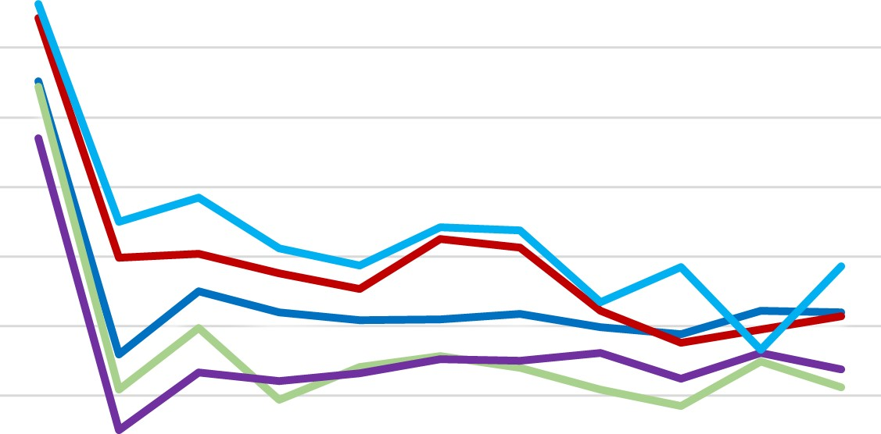
  All Female
  —All PHC
  All Greek All Student
  
3.7
3.6
3.5
3.4
3.3
3.2
3.1
3

S20 F 20 S21 F21 S22 F 22 S23 F 23 S24 F 24 S25

